

Plant A Home Program
PRE-SCREEN CHECKLIST

- Did you file tax return for prior calendar year? Yes No

- Are you ready to buy a home within the next six (6) months? Yes No

- Using the composition table below, do you meet income guidelines below? Yes No

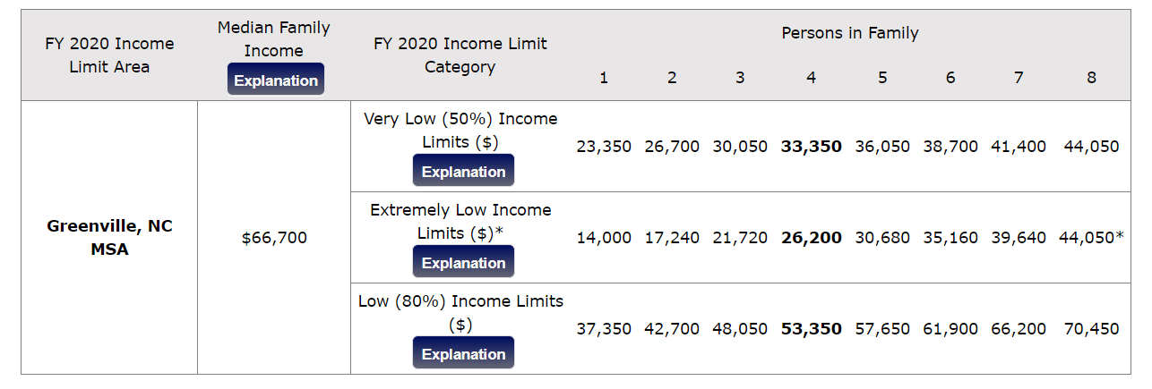
Income Table

EQUAL HOUSING OPPORTUNITY

If you’ve answered YES to all of the above questions, please come by the office located at 4316 Liberty Street, Ayden, NC 28513 to pick up an application.



EQUAL HOUSING OPPORTUNITY

EQUAL HOUSING OPPORTUNITY

EQUAL HOUSING OPPORTUNITY

EQUAL HOUSING OPPORTUNITY
Received on ___________________(date)
at ___________________________(time)
by __________________________(initials)
Plant-A-Home Program Application
APPLICANT’S NAME _________________________________ ADDRESS ________________________________________
PHONE # (_____)_______________ CELL #(_____)_______________
CITY_________________________ STATE ___________________________________ ZIP CODE __________
SOCIAL SECURITY # _________________________________ DATE OF BIRTH _________________
CO-APPLICANT’S NAME____________________________ RELATIONSHIP TO APPLICANT _______________________
PHONE # (_____)_______________ CELL #(_____)_______________
CITY_________________________ STATE ___________________________________ ZIP CODE __________
SOCIAL SECURITY # _________________________________ DATE OF BIRTH _________________
PRESENT RESIDENCE INFORMATION
PRESENT ADDRESS___________________________________________CITY_________________________
STATE ___________________________________ZIP CODE __________PHONE # (_____)_______________
Cell Phone # ________________________________________________________________________
HOW LONG AT THIS ADDRESS ________________ LANDLORD'S NAME___________________________
LANDLORD'S PHONE # (_____)_______________HOW MUCH IS YOUR CURRENT RENT? $ _________
WHY ARE YOU MOVING? ___________________________________________________________________
___________________________________________________________________________________________
PREVIOUS ADDRESS___________________________________________CITY_________________________
PREVIOUS LANDLORD'S NAME ________________________________ PHONE # (_____)_______________
WHEN WOULD YOU LIKE TO MOVE IN? ________________________________________________________
ARE YOU PLANNING TO BUY A HOME IN THE NEXT 6 MONTHS? __________________________________
HOW MANY PEOPLE WILL LIVE IN YOUR HOUSEHOLD? _________
Name __________________ Social Security No. ________________ Relationship _______________ Date of Birth_____________
Name __________________ Social Security No. ________________ Relationship _______________ Date of Birth_____________
Name __________________ Social Security No. ________________ Relationship _______________ Date of Birth_____________
Name __________________ Social Security No. ________________ Relationship _______________ Date of Birth_____________
NOTE: Social Security Number required for all household members.
EMERGENCY CONTACT PERSON
NAME _______________________________________________________ PHONE # (_____)_____________________
ADDRESS ____________________________________________________ RELATIONSHIP______________________
NAME _______________________________________________________ PHONE # (_____)_____________________
ADDRESS ____________________________________________________ RELATIONSHIP______________________
INCOME: List ALL money received by everyone in your household. This includes child support, contributions, Social Security, SSI, TANF, VA, Disability, retirement, rental property income, stock dividends, royalties, interest from bank accounts, alimony, unemployment, gifts, etc.
PERSON RECEIVING INCOME SOURCE OF INCOME AMOUNT OF INCOME
(per month/hourly rate, number of hours, etc.)
________________________________________________________________________________________________________
________________________________________________________________________________________________________
EMPLOYMENT REFERENCES:
1st APPLICANT’S EMPLOYER___________________________________________ SUPERVISOR'S NAME_________________________
DEPT __________ PHONE # (_____)_______________ LENGTH OF TIME EMPLOYED ______ YRS. _____MONTHS
POSITION____________________________ MONTHLY INCOME $___________________ ANY ADDITIONAL INCOME $_______________
2nd APPLICANT’S EMPLOYER___________________________________________ SUPERVISOR'S NAME ________________________
DEPT __________ PHONE # (_____)_______________ LENGTH OF TIME EMPLOYED ______ YRS. _____MONTHS
POSITION_____________________________ MONTHLY INCOME $___________________ ANY ADDITIONAL INCOME $_______________
DO YOU CURRENTLY HAVE UTILITIES IN YOUR NAME?____YES ____ NO
DO YOU OWN OR HAVE AN INTEREST IN ANY PROPERTY, LAND, HOUSES OR OTHER ASSETS? ____YES ____ NO
MARITAL STATUS ______MARRIED ______ UNMARRIED (includes single, divorced & widowed) ______SEPARATED

SEX ______MALE ______ FEMALE
HAVE YOU OR ANY MEMBER OF YOUR HOUSEHOLD BEEN CONVICTED OF A FELONY OR MISDEMEANOR WITHIN THE LAST TEN (10) YEARS?
If YES, explain: ________________________________________________________________________________
ARE THERE ANY PENDING CRIMINAL CHARGES?
If YES, explain: ________________________________________________________________________________
HAVE YOU EVER GONE THROUGH BANKRUPTCY, BEEN EVICTED, HAD ANY JUDGEMENTS, CREDITORS OR OTHER LEGAL PROCEEDING AGAINST YOU? __________________________________________________________
If YES, explain: ___________________________________________________________________________________

(Name of Applicant) (Date)

(Name of Applicant) (Date)
Interviewed By
(Date)

AUTHORIZATION TO RELEASE INFORMATION

I/ We, ____________________________ the undersigned hereby authorize all persons or companies in the categories listed below to release without liability information regarding employment, income, rental history, and/or assets to _______________________________ for purposes of verifying information on my/our rental housing application.

INFORMATION COVERED

I/We understand that previous or current information regarding me/us may be needed. Verifications and inquiries that may be requested include personal identity; rental history; employment history; income, assets, and medical or childcare allowances. I/We understand that this authorization cannot be used to obtain any information about me that is not pertinent to my eligibility for and continued participation as a qualified tenant.

GROUPS OR INDIVIDUALS THAT MAY BE ASKED

Past & Present Employers | Welfare Agencies | Veterans Administration
Previous Landlords (including Public Housing Agencies) | Retirement Systems | Social Security Administration
Banks | Support & Alimony Providers | Medical & Child Care Providers
Financial Institutions

CONDITIONS

I/We agree that a photocopy of tis authorization may be used for the purposes stated above. The original of this authorization is on file and will stay in effect for twelve (12) months from the date signed. I/We understand I/We have a right to review this file and correct any information that is incorrect.

I HAVE READ THE ABOVE AND I AM IN COMPLETE AGREEMENT WITH IT.
___________________________________________________________________  NAME OF APPLICANT | _______________  DATE
___________________________________________________________________  CO-APPLICANT | _______________  DATE

FRAUD
Chapter 157-29.1 of the North Carolina General Statues reads: Fraudulent misrepresentation.
- Any person whether provider or recipient, or person representing himself as such as, who willfully and knowingly and with intent to deceive makes a false statement or representation or who willfully and knowingly and with intent to deceive fails to disclose a material fact and as a result of making a false statement or representation or failing to disclose a material fact obtains, for himself or another person, attempts to obtain for himself or another person, or continues to receive housing assistance in the amount or value of not more than four hundred dollars ($400.00) is guilty of a misdemeanor, and upon conviction or plea of guilty shall be fined or imprisoned or both at the discretion of the court.

- Any person whether provider or recipient or person representing himself as such, who willfully and knowingly and with intent to deceive makes a false statement or representation or who willfully and knowingly and with intent to deceive fails to disclose a material fact and as result of making a false statement or representation or failure to disclose a material fact obtains for himself or another person, or continues to receive housing assistance in the amount or value of more than four hundred dollars ($400.00) is guilty of a Class I Felony.

Plant-A-Home (PAH) Program considers the misrepresentation of income and family circumstances to be serious policy violation as well as a crime and will take appropriate action if apparent fraud is discovered. Specifically:
- An applicant family who has misrepresented income and family circumstance may be declared ineligible for housing assistance.

- If any examination of the tenant’s file discloses that the tenant made any misrepresentation (at the time of admission or any previous reexamination date) which resulted in his/her being classified as eligible when in fact he/she was ineligible, the tenant may be required to vacate the apartment even though he/she may be currently eligible.

- The PAH Council shall report apparent cases of applicant fraud to the appropriate government agency. It shall be the policy of the Plant-A-Home program to press State and Federal authorities for prosecution of cases which, in the PAH Council’s judgement, appear to constitute willful and deliberate misrepresentation.

I have read this Fraud Statement on ____________________________________
(Date)

SIGNATURE: ___________________________________________

- Using the attached Parcel Maps, which Parcel would you like to purchase?
- First Choice
Street Name
Parcel Number
- Second Choice
Street Name
Parcel Number
- Third Choice
Street Name
Parcel Number

